UNIVERSITY OF WAH (UOW)
DEPARTMENT OF COMPUTER SCIENCE



BSCS 3RD B

REG #: UW-24-CS-BS-088

SUBMITTED BY: SAADI SAFDAR

SUBMITTED TO: SIR. HASSAN SHAFAQAT

COURSE TITLE: COMPUTER NETWORKS

COURSE CODE: CS – 241 L

LAB REPORT # 11

1. Objective
The objective of this lab is to simulate dynamic routing using Cisco Packet Tracer. The network consists of four PT routers, four PT switches, and eight end devices. The routers are interconnected using Serial DCE connections, while all other devices use FastEthernet links.

2. Network Topology
The network topology includes:
- 4 Routers connected through Serial DCE interfaces
- 4 Switches connected to the routers
- 8 End devices (PCs) connected to switches

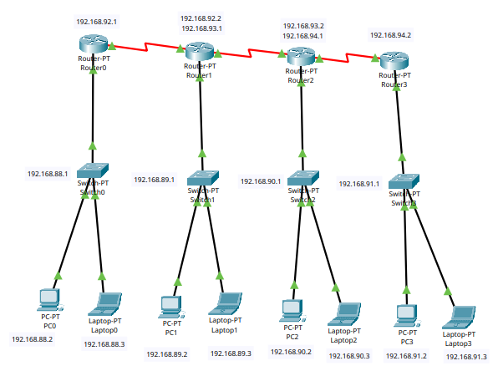

3. IP Addressing
IP addresses were assigned to all end devices, along with their default gateways. Router interfaces, including FastEthernet and Serial ports, were configured with appropriate IP addresses and subnet masks.

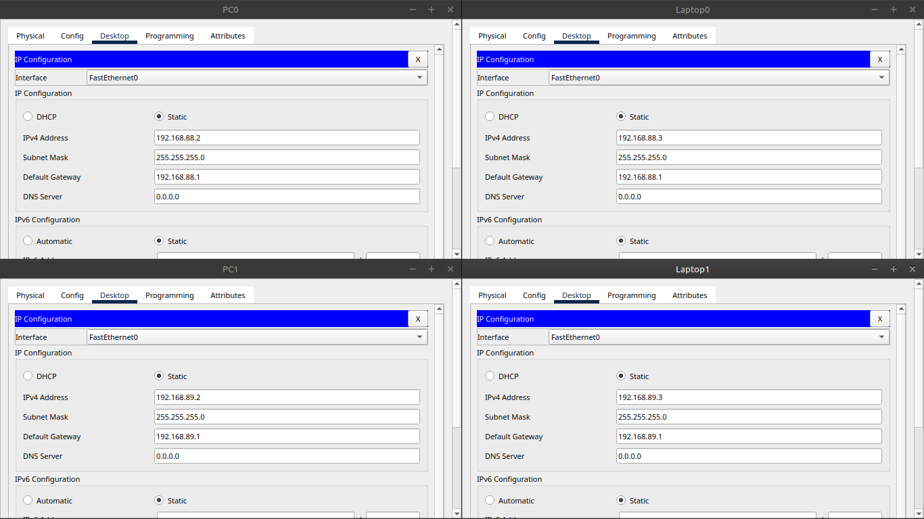
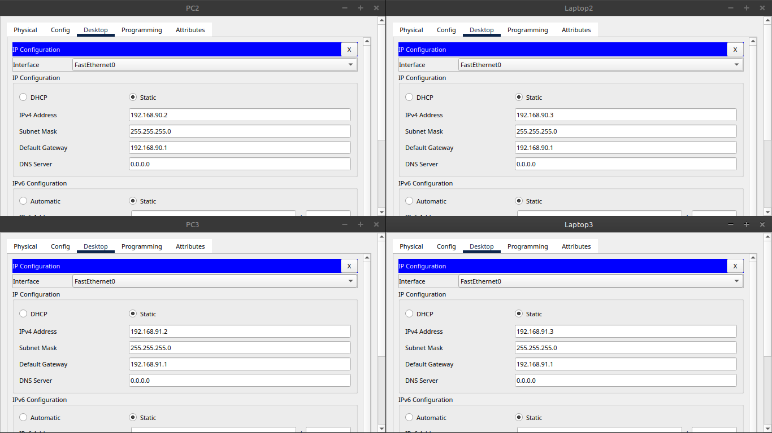

4. Router Configuration
Router configurations included:
- Assigning FastEthernet interface IP addresses
- Setting Serial interface IP addresses for inter-router connectivity
- Enabling RIP dynamic routing and adding network addresses

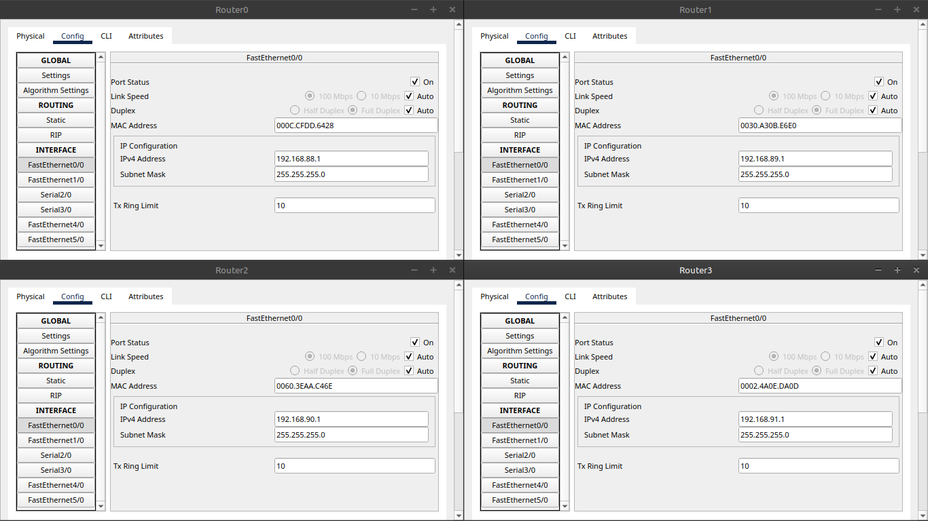

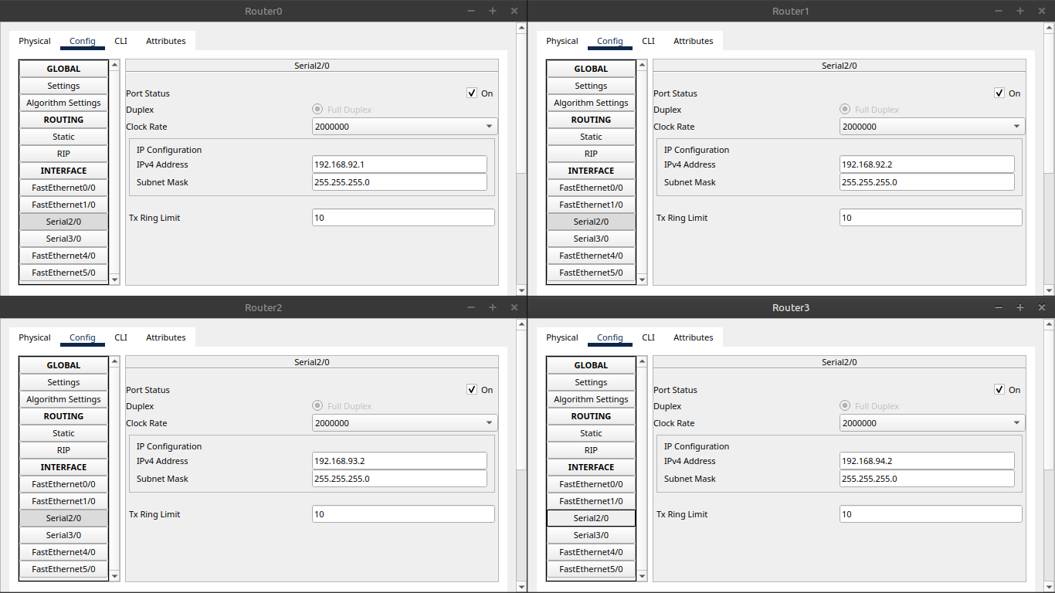

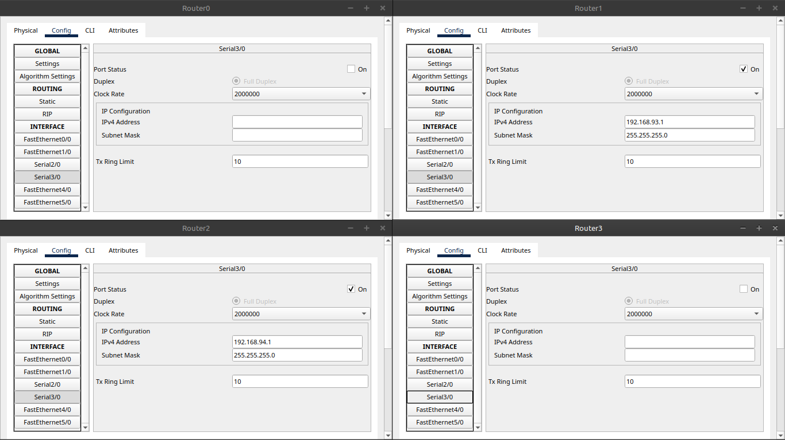

5. Dynamic Routing (RIP)
Routing Information Protocol (RIP) was configured on all routers by adding the respective network IDs. This enabled exchange of routing information dynamically among routers.

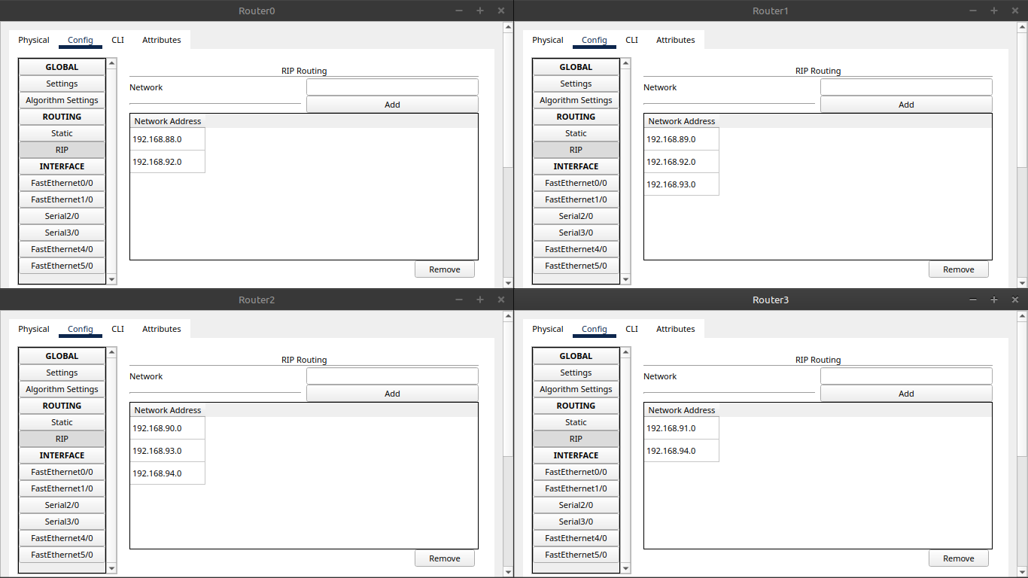

6. Testing & Verification
Ping tests were performed between all devices in the network. Successful transmission verified correct configuration and functioning of dynamic routing across the entire network.

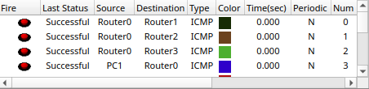

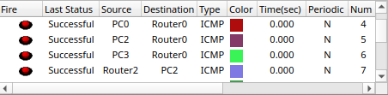

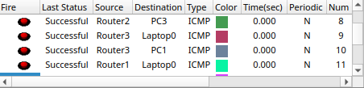

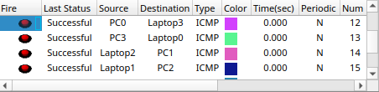

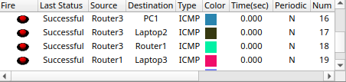

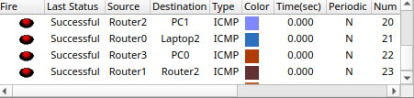

7. Conclusion
The lab successfully demonstrated dynamic routing using RIP in a multi-router environment. Network communication worked effectively across all connected devices.

